H2G2 game Phase 3 studios

<https://web.archive.org/web/20011026001326/http://www.phase3studios.com/project_hhg.html>

Welcome to Phase 3 Studios



|  |
| --- |
| *Phase 3 Studios was formed in 2000 as a joint venture between software publishers* Pan Interactive *and Douglas Adams' independent software development company,* The Digital Village, *in order to concentrate on the development of outstanding entertainment software.*  *Development of our first title,* [**The Hitchhikers Guide to the Galaxy**](https://web.archive.org/web/20020206063217/http:/phase3studios.com/project_hhg.html)*, is well under way.* |



[***[Home]***](https://web.archive.org/web/20020206063217/http:/phase3studios.com/index.html)  [***[Douglas Adams]***](https://web.archive.org/web/20020206063217/http:/www.douglasadams.com/)  [***[Projects]***](https://web.archive.org/web/20020206063217/http:/phase3studios.com/project_hhg.html)  [***[News]***](https://web.archive.org/web/20020206063217/http:/phase3studios.com/news.html)  [***[Contacts]***](https://web.archive.org/web/20020206063217/http:/phase3studios.com/contacts.html)

The Hitchhikers Guide to the Galaxy



|  |
| --- |
| ***History***  In 1971, while hitchhiking in Europe, [Douglas Adams](https://web.archive.org/web/20011026001326/http:/www.douglasadams.com/) was lying in a field near Innsbruck and it occurred to him that somebody should write a hitchhikers guide - the ultimate hitchhikers guide - a guide to the Galaxy.  Much to his subsequent surprise, this became the inspiration for an earth-shattering science-fiction/comedy radio series for the BBC, *The Hitchhikers Guide to the Galaxy*, first aired in 1978. From this was born a [wholly remarkable book](https://web.archive.org/web/20011026001326/http:/www.douglasadams.com/creations/0345391802.html) which snowballed into a trilogy (albeit in 5 parts), a BBC television series, and an infuriatingly ingenious computer text-based adventure.  Realising that computers were not yet powerful enough to fully realise his vision, Douglas allowed his ideas for computer entertainment projects to rest until the world was at last ready for them. He returned to the computer entertainment scene in 1999 with the release of *Starship Titanic*, an interactive adventure game.  Following this, his team moved on to development of an immersive 3D adventure game based upon *The Hitchhikers Guide to the Galaxy*.  ***The Game***  Control the hapless and disoriented *Arthur Dent* as his trip downstairs to fetch the morning paper is interrupted by the destruction of the Earth and begins a quest to thwart the plans of an invasion force of Krikkit robots, bent (as always happens in such stories) on the total annihilation of all life in the universe.  Assisted by his friend *Ford Prefect* (who is not actually an out-of-work Actor from Guildford as he claims, but actually from a small planet somewhere in the vicinity of Betelgeuse) and the unlikely crew of the *Heart of Gold* - *Zaphod Beeblebrox*, the two-headed, three-armed ex-hippie and totally out-to-lunch President of the Galaxy; *Trillian*, Earth's only surviving astrophysicist; and *Marvin the Paranoid Android*, a robot who makes the worst known case of clinical depression seem like the merest self-indulgent whim - Arthur sets out on a quest that takes him from the most squalid surroundings of a Vogon Constructor Fleet spaceship to the extensive swamplands of Squornshellous Zeta, to the planet-construction yards of the legendary Magrathea, and the fabled Argabuthon Halls of Justice, with perhaps just enough time to see some sights and crash a party or two along the way.  To top off an otherwise pretty below-average day, Arthur somehow has to cope without a decent cup of tea.  [Click for enlargement](https://web.archive.org/web/20011026001326/http:/www.phase3studios.com/hhg_image_shot1.html)[Click for enlargement](https://web.archive.org/web/20011026001326/http:/www.phase3studios.com/hhg_image_shot2.html)[Click for enlargement](https://web.archive.org/web/20011026001326/http:/www.phase3studios.com/hhg_image_shot3.html)[Click for enlargement](https://web.archive.org/web/20011026001326/http:/www.phase3studios.com/hhg_image_shot4.html) [Click for enlargement](https://web.archive.org/web/20011026001326/http:/www.phase3studios.com/hhg_image_shot5.html)[Click for enlargement](https://web.archive.org/web/20011026001326/http:/www.phase3studios.com/hhg_image_shot6.html)[Click for enlargement](https://web.archive.org/web/20011026001326/http:/www.phase3studios.com/hhg_image_shot7.html)[Click for enlargement](https://web.archive.org/web/20011026001326/http:/www.phase3studios.com/hhg_image_shot8.html) |



[***[Home]***](https://web.archive.org/web/20011026001326/http:/www.phase3studios.com/index.html)  [***[Douglas Adams]***](https://web.archive.org/web/20011026001326/http:/www.douglasadams.com/)  [***[Projects]***](https://web.archive.org/web/20011026001326/http:/www.phase3studios.com/project_hhg.html)  [***[Contacts]***](https://web.archive.org/web/20011026001326/http:/www.phase3studios.com/contacts.html)

***Inside a Krikkit Warship***

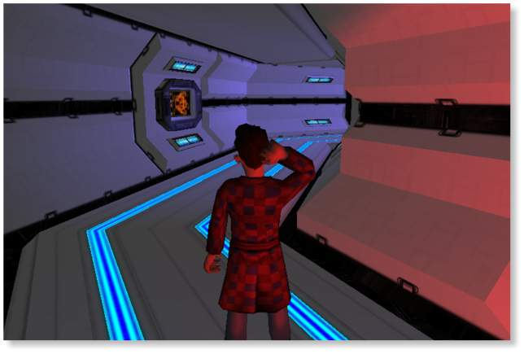  
[***[Back to Article]***](https://web.archive.org/web/20011205204132/http:/phase3studios.com/project_hhg.html)

***A Magrathean Corridor***

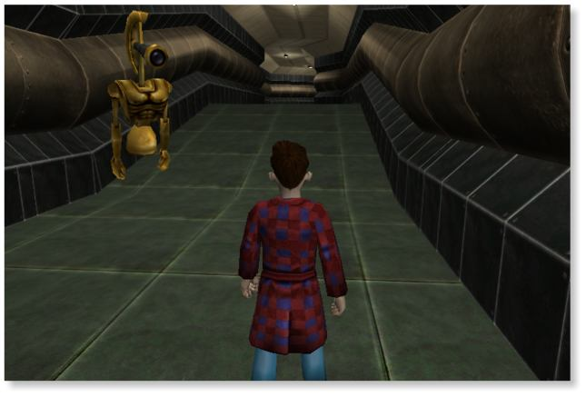  
[***[Back to Article]***](https://web.archive.org/web/20020220230653/http:/phase3studios.com/project_hhg.html)

***Wandering the halls...***

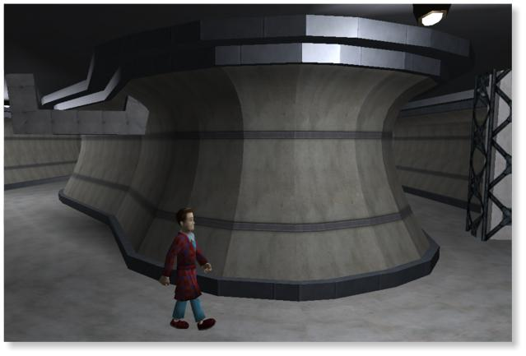  
[***[Back to Article]***](https://web.archive.org/web/20020216115614/http:/www.phase3studios.com/project_hhg.html)

***Wandering the halls...***

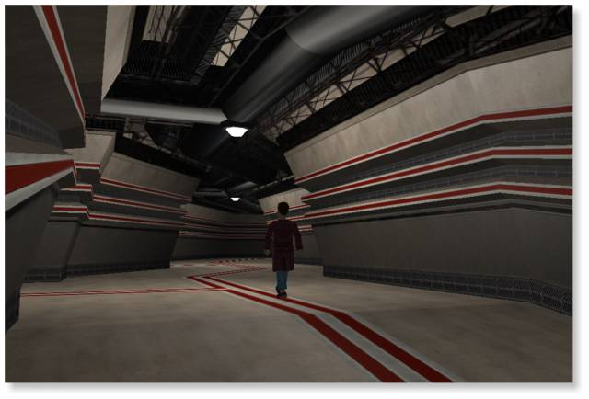  
[***[Back to Article]***](https://web.archive.org/web/20011205130838/http:/phase3studios.com/project_hhg.html)

***Consulting with the Monks***

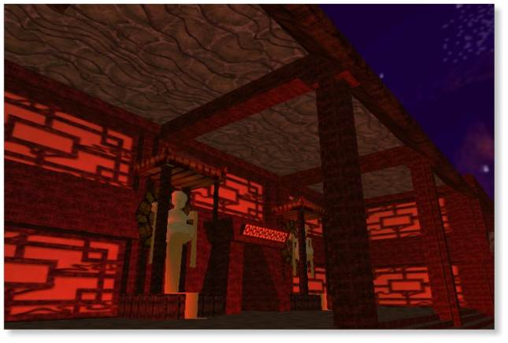  
[***[Back to Article]***](https://web.archive.org/web/20020126092931/http:/www.phase3studios.com/project_hhg.html)

***Walking on the Moon***

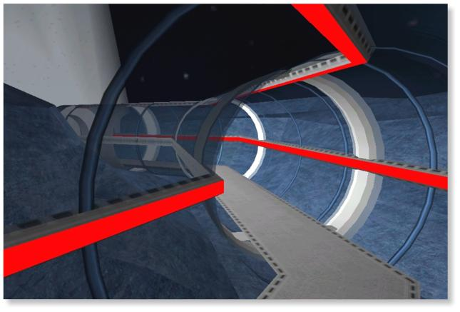  
[***[Back to Article]***](https://web.archive.org/web/20020220202213/http:/phase3studios.com/project_hhg.html)

The Hitchhikers Guide to the Galaxy



|  |
| --- |
| ***Press Release***  Douglas Adams's hugely popular story, The Hitchhiker's Guide to the Galaxy has not only been a highly successful radio show, but also spawned a number one best-selling novel and a TV series. Now it's set to conquer the gaming world again.  A 3D 'towel'em up' arcade adventure game based on the comedy sci-fi classic will be released May 2002 on PC CD-Rom to coincide with the launch of Adams's final novel, [*The Salmon of Doubt*](https://web.archive.org/web/20011228224452/http:/www.amazon.com/exec/obidos/ASIN/1400045088/pelmanism-20).  The game, promising action, adventure - and of course, Douglas's inimitable brand of comedy, has been developed by the games division of his own former company, *The Digital Village*. Touting the new name [*Phase 3 Studios Ltd*](https://web.archive.org/web/20011228224452/http:/www.phase3studios.com/), they're now part of Swedish giant KF Media.  The Hitchhiker's Guide to the Galaxy, a cult trilogy (in five parts), has sold over 15 million copies worldwide, been translated into almost every language (except Vogon) and enjoys a universal audience of all ages.  This unique gaming experience will appeal to players who have never read a Douglas Adams novel, as well as to his many dedicated fans.  Launch date: May 2002 Developers: Phase 3 Studios Publishers: Pan Interactive  More information to follow after the Holiday Season enquiries to press@phase3studios.com |



[***[Home]***](https://web.archive.org/web/20011228224452/http:/www.phase3studios.com/index.html)  [***[Douglas Adams]***](https://web.archive.org/web/20011228224452/http:/www.douglasadams.com/)  [***[Projects]***](https://web.archive.org/web/20011228224452/http:/www.phase3studios.com/project_hhg.html)  [***[Contacts]***](https://web.archive.org/web/20011228224452/http:/www.phase3studios.com/contacts.html)

Phase 3 Studios - Contacts



*Phase 3 Studios,*  
Floor 1,  
Gainsborough Business Centre,  
100 Pall Mall,  
St James's,  
London SW1Y 5HP,  
United Kingdom.

*Email* - [info@phase3studios.com](https://web.archive.org/web/20011205033027/mailto:info@phase3studios.com)

*Phone* - +44 207 664 8798  
*Facsimile* - +44 207 664 8799





[***[Home]***](https://web.archive.org/web/20011205033027/http:/phase3studios.com/index.html)  [***[Douglas Adams]***](https://web.archive.org/web/20011205033027/http:/www.douglasadams.com/)  [***[Projects]***](https://web.archive.org/web/20011205033027/http:/phase3studios.com/project_hhg.html)  [***[Contacts]***](https://web.archive.org/web/20011205033027/http:/phase3studios.com/contacts.html)

<https://web.archive.org/web/20010417021147/http://www.noblepr.co.uk/Press_Releases/pan/hitch_making.htm>

|  |  |  |  |  |  |  |  |  |  |  |  |  |  |  |  |  |  |  |  |  |  |  |  |  |  |  |  |  |  |  |  |
| --- | --- | --- | --- | --- | --- | --- | --- | --- | --- | --- | --- | --- | --- | --- | --- | --- | --- | --- | --- | --- | --- | --- | --- | --- | --- | --- | --- | --- | --- | --- | --- |
| |  |  | | --- | --- | | PAN Interactive on the Making of The Hitchhiker's Guide to the Galaxy computer game**29/03/2001** | [Click for hi-res image](https://web.archive.org/web/20010417021147/http:/www.noblepr.co.uk/images/logos/Pan.jpg) [**www.paninteractive.se**](https://web.archive.org/web/20010417021147/http:/www.paninteractive.se/) |  |  | | --- | |  | | **PAN Interactive** today announced the development and interactive adaptation of **Douglas Adams'** best-selling book, ***The Hitchhiker's Guide to the Galaxy***, into a PC CD-ROM game. The game is currently being developed in London by **PAN H2G2** and will be released worldwide during Q1 2002.  **PAN** are pitching ***The Hitchhiker's Guide to the Galaxy*** game as an incredibly amusing third person, real-time 3D arcade towel 'em up adventure in the mould of Tomb Raider, Mario 64 and Zelda. The game combines action, adventure and comedy into an immersive game environment that remains true to the spirit of Douglas Adams' popular Sci-Fi novels.   |  |  |  | | --- | --- | --- | | [Click for hi-res image](https://web.archive.org/web/20010417021147/http:/www.noblepr.co.uk/Press_Releases/pan/images/hitch_making/marvin.jpg) Marvin | Vogon | [Click for hi-res image](https://web.archive.org/web/20010417021147/http:/www.noblepr.co.uk/Press_Releases/pan/images/hitch_making/clerc.jpg) Clerc |   The engaging and amusing game is based on the best selling book ***The Hitchhiker's Guide to the Galaxy*** that has sold 15 million copies worldwide. The game utilises the rich environment and characters from the books, and successfully captures Douglas Adams' trademark humour and wit. The game will be entertaining to people who have never read a Douglas Adams novel, as well as to dedicate die-hard fans.  The player controls the actions of **Arthur Dent** as he is unwittingly plucked from Earth just minutes before it's global destruction. Afterwards he bounces from one mind-boggling situation to another.  During the course of his adventures, Arthur comes across a wide variety of strange and fantastic creatures and characters, both friendly and hostile, including Bugblatter beasts, Dentrassi cooks, mattresses, Vogons and Krikkits. In addition, all the popular characters from the original book make an appearance, including Zaphod, Marvin Ford and Slartibartfast.   |  |  |  | | --- | --- | --- | | [Click for hi-res image](https://web.archive.org/web/20010417021147/http:/www.noblepr.co.uk/Press_Releases/pan/images/hitch_making/Dentrassi.jpg) Dentrassi | [Click for hi-res image](https://web.archive.org/web/20010417021147/http:/www.noblepr.co.uk/Press_Releases/pan/images/hitch_making/TowelinMonk.jpg) Towelin Monk | [Click for hi-res image](https://web.archive.org/web/20010417021147/http:/www.noblepr.co.uk/Press_Releases/pan/images/hitch_making/bugblatter.jpg) Bug Blatter |   The Hitchhiker's Guide to the Galaxy PC CD-ROM game features -   * Stunning graphics and animations * Fascinating storyline * Wonderful humorous gameplay * Improbable events and a host of colourful characters   The game is developed by some of the original team who created Dougals Adams' successful ***Starship Titantic*** PC CD game  **PAN** is positioning the game at a wide demographic including males and females aged 12-35. This audience will already be familiar with the Hitchhiker's Guide series, and will have a keen interest in computer games (particularly third person perspective arcade adventure games) and the Internet.   |  |  | | --- | --- | | **Other Relevant Pan Interactive Press Releases** | | | **1.** | [**PAN Interactive Announce the Swedish/British Co-Development of Douglas Adams' Hitchhiker's Guide to the Galaxy PC CD-ROM**](https://web.archive.org/web/20010417021147/http:/www.noblepr.co.uk/Press_Releases/pan/hitch_main.htm) | | **2.** | [**Introducing "PAN Interactive AB" - The Nordics' Leading Games Producer of Interactive Entertainment**](https://web.archive.org/web/20010417021147/http:/www.noblepr.co.uk/Press_Releases/pan/hitch_overview.htm) | | **3.** | [**PAN Interactive on the Making of The Hitchhiker's Guide to the Galaxy computer game**](https://web.archive.org/web/20010417021147/http:/www.noblepr.co.uk/Press_Releases/pan/hitch_making.htm) |  |  |  | | --- | --- | |  | **For further information please contact  Peter Noble @ PETER NOBLE PR Graphic House, 2A Sumatra Road London, NW6 1PU Tel: 020 7794 2302 Fax: 020 7431 9984 E-mail:** [**peter@noblepr.co.uk**](https://web.archive.org/web/20010417021147/mailto:peter@noblepr.co.uk) | |  |  |  |  |  |  |  |  |  |  |  |  | | --- | --- | --- | --- | --- | --- | --- | --- | --- | --- | --- | |  | [Home](https://web.archive.org/web/20010417021147/http:/www.noblepr.co.uk/) |  | [Brochure](https://web.archive.org/web/20010417021147/http:/www.noblepr.co.uk/brochure.htm) |  | [Clients](https://web.archive.org/web/20010417021147/http:/www.noblepr.co.uk/clients.htm) |  | [Press Releases](https://web.archive.org/web/20010417021147/http:/www.noblepr.co.uk/whatsnew.htm) |  | [How to find us](https://web.archive.org/web/20010417021147/http:/www.noblepr.co.uk/how_to_find_us.htm) |  | |

|  |  |  |  |  |  |  |  |  |  |  |  |  |  |  |  |  |  |  |  |  |  |  |  |  |  |  |  |  |  |  |  |  |
| --- | --- | --- | --- | --- | --- | --- | --- | --- | --- | --- | --- | --- | --- | --- | --- | --- | --- | --- | --- | --- | --- | --- | --- | --- | --- | --- | --- | --- | --- | --- | --- | --- |
| |  |  | | --- | --- | | PAN Interactive Announce the Swedish/British  Co-Development of Douglas Adams'  Hitchhiker's Guide to the Galaxy PC CD-ROM**29/03/2001** | [Click for hi-res image](https://web.archive.org/web/20010405115452/http:/www.noblepr.co.uk/images/logos/Pan.jpg) [**www.paninteractive.se**](https://web.archive.org/web/20010405115452/http:/www.paninteractive.se/) |  |  | | --- | |  | | |  |  | | --- | --- | | [[Click for hi-res image](https://web.archive.org/web/20010405115452/http:/www.noblepr.co.uk/Press_Releases/pan/images/hitch_main/arthur.jpg)](https://web.archive.org/web/20010405115452/http:/www.noblepr.co.uk/Press_Releases/pan/images/hitch_main/arthur.jpg) Arthur Dent | **London, England, Thursday 29th 2001** - The Nordic's leading publisher and developer of interactive entertainment, **PAN Interactive**, today announced follow-up to Britain's premier Sci-Fi author, **Douglas Adam's *Starship Titantic*** PC CD-Rom game, with the computer game publishing rights to **The Hitchhiker's Guide to the Galaxy**. Adapted from the top-selling book that has sold 15 million copies worldwide, the PC CD-ROM adaptation is being developed as an exciting third person, real-time 3D arcade towel 'em up adventure in the mould of Tomb Raider, Mario 64 and Zelda.  **PAN** has initiated a development joint venture between the original **UK based** development team, **The Digital Village**, who was responsible for ***Starship Titanic***. Entitled "**PAN H2G2**", PAN Interactive will hold a 65% stake in the joint venture, and are currently developing the game with a 20-strong team at PAN H2G2's studios in Convent Garden, London. |  |  |  | | --- | --- | | [Click for hi-res image](https://web.archive.org/web/20010405115452/http:/www.noblepr.co.uk/Press_Releases/pan/images/hitch_main/adams.jpg) Douglas Adams, author of The Hitchhiker's Guide to the Galaxy | [Click for hi-res image](https://web.archive.org/web/20010405115452/http:/www.noblepr.co.uk/Press_Releases/pan/images/hitch_main/DentrassiFryingpan.jpg) Dentrassi |  |  |  | | --- | --- | | "We are very excited about the prospect of the PC adaptation of Hitchhiker," says **Henrik Eklund**, CEO of PAN Interactive. "H2G2 have developed an exclusive 3D engine to support the game, and I believe anyone who was a fan of Douglas Adams' original book, will fall in love with the addictive gaming qualities and hooks the game has to offer. We're looking forward to previewing Hitchhiker at E3 in May."  With projected release in Q1 2002, PAN Interactive retain the global publishing rights for the ***Hitchhiker's Guide to the Galaxy*** PC game. UK distribution rights for the game are currently under negotiation. | [Click for hi-res image](https://web.archive.org/web/20010405115452/http:/www.noblepr.co.uk/Press_Releases/pan/images/hitch_main/henrik.jpg) Henrik Eklund,CEO of PAN Interactive |  |  | | --- | | **About PAN Interactive** In September 2000, O-listed Enlight Interactive's subsidiary IQ Media merged with KF's PAN Interactive Publishing. The new company, PAN Interactive AB, which is 75% owned by Enlight Interactive (the Nordic's biggest E-Learning Company for Online Education) and 25% by KF Media (part of the largest FMCG company in Scandinavia), boasts the gaming, toy and television rights to The Hitchhiker's Guide to the Galaxy, Diablo, Backpacker and Star Trek. PAN Interactive also holds the exclusive rights for the development and maintenance for the official website of Astrid Lindgren, the renowned Swedish author of the Pippy Longstocking books.  PAN hold the distribution rights in Scandinavia for computer games published by Vivendi Universal, Activision and 3DO.  PAN Interactive restructured its Nordic organisation in October 2000 to accommodate a more focused global strategy in the gaming market. Company revenues for 2000-2001 is projected to reach SEK 160-180 million. PAN Interactive continues to build strategic distribution partnerships in Britain, Germany, USA and Southeast Asia, and will continue strong global expansion throughout 2001.  Between 1995-1999, revenues from the computer games industry in America doubled from SEK 30 billion to over SEK 60 billion. In Sweden branch revenues surpassed SEK 700 million in 1999 and the industry anticipates a continued annual growth of 20%. This is attributed to the fact that games are reaching a wider audience that attracts new buyers.  * At the time of writing, one UK Pound Sterling is worth 14.70 SEK (Swedish kroner) |  |  |  | | --- | --- | | **Other Relevant Pan Interactive Press Releases** | | | **1.** | [**PAN Interactive Announce the Swedish/British Co-Development of Douglas Adams' Hitchhiker's Guide to the Galaxy PC CD-ROM**](https://web.archive.org/web/20010405115452/http:/www.noblepr.co.uk/Press_Releases/pan/hitch_main.htm) | | **2.** | [**Introducing "PAN Interactive AB" - The Nordics' Leading Games Producer of Interactive Entertainment**](https://web.archive.org/web/20010405115452/http:/www.noblepr.co.uk/Press_Releases/pan/hitch_overview.htm) | | **3.** | [**PAN Interactive on the Making of The Hitchhiker's Guide to the Galaxy computer game**](https://web.archive.org/web/20010405115452/http:/www.noblepr.co.uk/Press_Releases/pan/hitch_making.htm) |  |  |  | | --- | --- | |  | **For further information please contact  Peter Noble @ PETER NOBLE PR Graphic House, 2A Sumatra Road London, NW6 1PU Tel: 020 7794 2302 Fax: 020 7431 9984 E-mail:** [**peter@noblepr.co.uk**](https://web.archive.org/web/20010405115452/mailto:peter@noblepr.co.uk) | |  |  |  |  |  |  |  |  |  |  |  |  | | --- | --- | --- | --- | --- | --- | --- | --- | --- | --- | --- | |  | [Home](https://web.archive.org/web/20010405115452/http:/www.noblepr.co.uk/) |  | [Brochure](https://web.archive.org/web/20010405115452/http:/www.noblepr.co.uk/brochure.htm) |  | [Clients](https://web.archive.org/web/20010405115452/http:/www.noblepr.co.uk/clients.htm) |  | [Press Releases](https://web.archive.org/web/20010405115452/http:/www.noblepr.co.uk/whatsnew.htm) |  | [How to find us](https://web.archive.org/web/20010405115452/http:/www.noblepr.co.uk/how_to_find_us.htm) |  | |

|  |  |  |  |  |  |  |  |  |  |  |  |  |  |  |  |  |  |  |  |  |  |  |  |  |  |
| --- | --- | --- | --- | --- | --- | --- | --- | --- | --- | --- | --- | --- | --- | --- | --- | --- | --- | --- | --- | --- | --- | --- | --- | --- | --- |
| |  |  | | --- | --- | | Introducing "PAN Interactive AB" - The Nordics' Leading Games Producer of Interactive Entertainment**29/03/2001** | [Click for hi-res image](https://web.archive.org/web/20010417021927/http:/www.noblepr.co.uk/images/logos/Pan.jpg) [**www.paninteractive.se**](https://web.archive.org/web/20010417021927/http:/www.paninteractive.se/) |  |  | | --- | |  | | In September 2000, O-listed **\*Enlight Interactive's** subsidiary IQ Media merged with KF's **PAN Interactive Publishing**. The new company, **PAN Interactive AB**, which is 75% owned by Enlight Interactive and 25% by **\*KF Media**, boasts the gaming rights to **The Hitchhiker's Guide to the Galaxy**. The company also has the Nordic distribution rights to ***Diablo*** via a Nordic joint venture with Vivendi Universal, which enables PAN to distribute the latter's PC titles throughout Scandinavia.  **PAN** also have the gaming rights to the **Star Trek Deep Space Nine *The Fallen*** and ***Dominion Wars*** **PC CD-Rom** games worldwide, excluding America, which are co-published by **Simon & Schuster Interactive**.  **PAN Interactive** also holds the exclusive gaming rights for the new ***Pippi Longstocking*** children's PC CD-Rom game, and oversees the development and maintenance of the official website for **Astrid Lindgren**, the renowned Swedish author of the ***Pippi Longstocking*** books. The books have been translated into more than 70 languages and have sold more than 80 million copies worldwide.  The repositioning of the company name and trademark is part of PAN Interactive's efforts to continually adapt to new market conditions, and a way to project a more focused profile to market and media. Re-focusing will also help to further increase the level of service to Nordic customers and international publishers such as **Vivendi Universal**, **Activision**, and **3DO**.  **PAN Interactive** restructured its Nordic organisation in October 2000 to accommodate a more focused strategy in the gaming market. Company revenues for 2000-2001 is projected to reach SEK 160-180 million. PAN Interactive continues to expand in Britain, Germany, USA and Southeast Asia, and will continue strong global expansion throughout 2001.  "We are now in a position to place greater emphasis on our portfolio, which includes the global rights to such international trademarks as ***Rosemond Valley***, ***The Hitchhiker's Guide to the Galaxy*** and ***Intergalactic Bounty Hunter***," says **PAN Interactive CEO Henrik Eklund**. "Since we own the majority of the value chain and are able to exploit a global market, we are able to spread our risk and maximise our potential for growth. By controlling the rights we can also generate profitable income streams from other media including books, toys and TV."  Between 1995-1999, revenues from the computer games industry in America doubled from SEK 30 billion to over SEK 60 billion. In Sweden branch revenues surpassed SEK 700 million in 1999 and the industry anticipates a continued annual growth of 20%. This is attributed to the fact that games are reaching a wider audience that attracts new buyers.  * KF Media is part of Scandinavia's largest FMCG company. * Enlight Interactive is the Nordic's biggest E-Learning Company for Online Education.   |  |  | | --- | --- | | **Other Relevant Pan Interactive Press Releases** | | | **1.** | [**PAN Interactive Announce the Swedish/British Co-Development of Douglas Adams' Hitchhiker's Guide to the Galaxy PC CD-ROM**](https://web.archive.org/web/20010417021927/http:/www.noblepr.co.uk/Press_Releases/pan/hitch_main.htm) | | **2.** | [**Introducing "PAN Interactive AB" - The Nordics' Leading Games Producer of Interactive Entertainment**](https://web.archive.org/web/20010417021927/http:/www.noblepr.co.uk/Press_Releases/pan/hitch_overview.htm) | | **3.** | [**PAN Interactive on the Making of The Hitchhiker's Guide to the Galaxy computer game**](https://web.archive.org/web/20010417021927/http:/www.noblepr.co.uk/Press_Releases/pan/hitch_making.htm) |  |  |  | | --- | --- | |  | **For further information please contact  Peter Noble @ PETER NOBLE PR Graphic House, 2A Sumatra Road London, NW6 1PU Tel: 020 7794 2302 Fax: 020 7431 9984 E-mail:** [**peter@noblepr.co.uk**](https://web.archive.org/web/20010417021927/mailto:peter@noblepr.co.uk) | |  |  |  |  |  |  |  |  |  |  |  |  | | --- | --- | --- | --- | --- | --- | --- | --- | --- | --- | --- | |  | [Home](https://web.archive.org/web/20010417021927/http:/www.noblepr.co.uk/) |  | [Brochure](https://web.archive.org/web/20010417021927/http:/www.noblepr.co.uk/brochure.htm) |  | [Clients](https://web.archive.org/web/20010417021927/http:/www.noblepr.co.uk/clients.htm) |  | [Press Releases](https://web.archive.org/web/20010417021927/http:/www.noblepr.co.uk/whatsnew.htm) |  | [How to find us](https://web.archive.org/web/20010417021927/http:/www.noblepr.co.uk/how_to_find_us.htm) |  | |